A New Brunswick Winter Scene - 1934

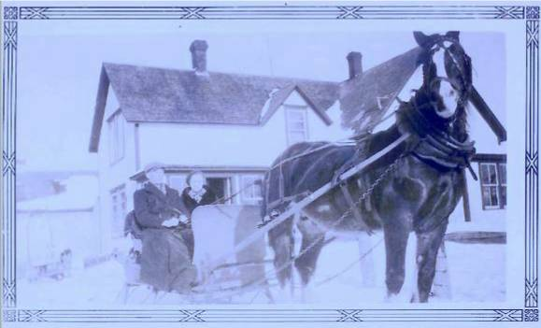

Season’s Greetings

A New Brunswick Winter Scene - 1934

Season’s Greetings

Photo shows Walter and Venetia Glendenning in front of
The Glendenning residence at Little Branch, N.B.
- from the collection of Venetia (Glendenning) Russell

Wishing you

A joyful heart
a loving home
a peaceful world.

Photo shows Walter and Venetia Glendenning in front of
the Glendenning residence at Little Branch, N.B.
- from the collection of Venetia (Glendenning) Russell

Wishing you
a joyful heart
a loving home
a peaceful world.

